

Project Report

Course Title: Data Structure

Course Code: CSE134

Project Title: Food Order in a Restaurant

Submitted To

**Zakia Zaman**

Lecturer

Daffodil International University

Submitted By

Md. Rasel Khandakar ⇨161-15-7040

Obaydullah Ranu ⇨163-15-8491

A.S.M Abir ⇨163-15-8404

Md. Musfiqur Rahman Foysal ⇨163-15-8489

Abstract

It’s a small restaurant. Practically, customers have to make their order by choosing food from our given food menu list. It is work as the programme Queue. Queue follows the **First In First Out (FIFO)** rule - the item that goes in first is the item that comes out first too. So that who order first he/she gets his/her food serve first. And after taking orders we provide the bill to the customers and customers has to pay the bill. Conclude that insist of the program cause more efficiency to the restaurant.

Table of Content

Chapter-1

* Introduction.

Chapter-2

* Project Demo
* Input
* Output

Chapter-3

* Advantages
* Disadvantages
* Limitations

Chapter-4

* Future Possibilities & Improvement.

Chapter-5

* Conclusion

**Chapter-1**

**Project Title**

Write a program to manage Food order in a restaurant. In a restaurant, the food order contains food number, size, and quantity. The order is served in the form of first come first serve basis. You program will display total number of orders received, served and waiting at any point in time.

**Introduction**

The project requires to make a program which will help to automate the process of food order and delivery system in a restaurant. The program will ask customer to enter the food he/she want to take from a given list. Then will ask to enter the desired quantity of that item. And when asked to display the program will show the number of order received, number of order delivered and the total number of currently waiting order. And importantly the orders will be served on first come first serve basis. Which indicated the first order will be delivered at first.

**Difficulty**

Medium

**Input**

The program will take input for choosing option from menu. Then will engage according to the selection.

**Order:** Choosing order will call order function which will take name of the customer then it will show the list of food items and ask to input number of items to order. After selecting this it will ask for chosen items then for every item it will ask for the size of the item (if available). After the requested input, the order will complete showing a message containing customer’s name and amount of food ordered.

**Serve**: Serve will show the customer’s name whose order is being served

**Display:** Display will show

* Total number of order taken
* Total number of order served
* Number of order waiting to be served
* Order number of the order that is being processed currently at any time of command.

**Output**

Output contains everything that is displayed in the display function.

**Language(s) used**

The complete program is written in ANSII C language. All library files used here are libraries of C.

**IDE used**

Code::Blocks (v16.01)

**Testing and Validation**

The program was tested using many of different inputs needed accordingly to see the outputs. And the program successfully delivered the desired output at any time of command.

Program was run several times with different inputs by team members.

**Design and Basic Idea**

The program uses queue technique as basic idea. Using queue, we can get a series come and go on first come first out basis. The program contains one structure which holds the data for each order and several functions with different necessity. Main function of the program calls all the function as of necessity. The program runs until user wants it to stop. Therefore, the program won’t stop at any point of time.

Chapter-2

**Project Demo**

**Input:**

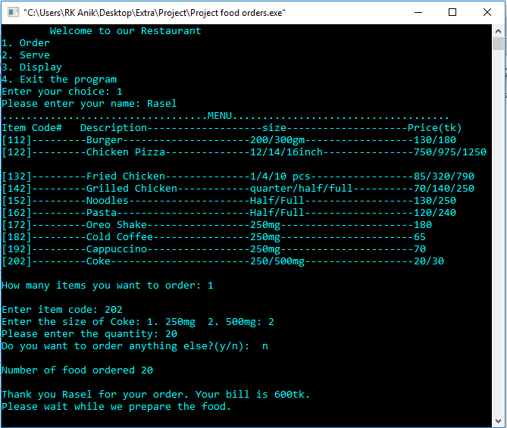

**Output:**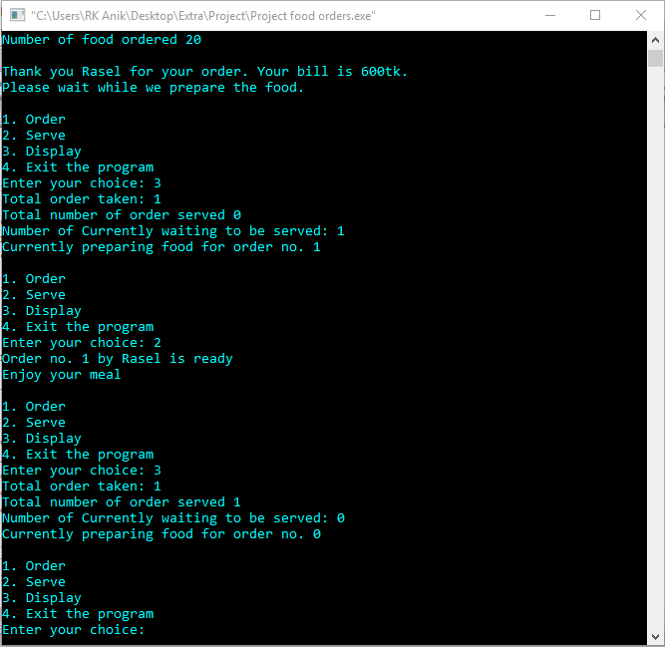

**Usage in Real Life**

This program can be used in Food courts or restaurants to maintain the food orders and keep everything under surveillance. Although this program contains a few items in list the list can be bigger and with more options as necessary.

**Chapter-3**

**Advantages**

This program will help restaurants to manage food orders more easily. Busy shops have serving queue problems sometimes. This program will help to maintain the queue automatically on first come first serve basis. It can be easily used to make bills too. And last but not least this will show who to serve next along with the customers in line to be served.

**Disadvantages and Limitations**

This program is a console program which is not user friendly. The interface is quite difficult to input data normally. This program is built using array which has limitation of 10000 according to the code which indicates it will allow up to 10000 orders and serves but no more.

Chapter-4

**Future Possibilities and Improvements**

Upgrading this program, we can create more suitable food management system. Which can even be capable of keeping records of previous records. Adding a user-friendly GUI can make this program usable by everyone. It can more item list than it has in it. With a few adjustments, we can even make a way to change any order that has already been placed. It will bring a little complexity to source code but will surely be helpful. This can be used in AI for automated home delivery system.

Chapter-5

**Conclusion**

This program is full of potential to help people managing orders and saving times. It can be helpful for both customers and restaurant owner or manager.

**References**

www.learncpp.comwww.youtube.com

[www.stackoverflow.com](http://www.stackoverflow.com)www.en.wikipedia.com

[www.github.com](http://www.github.com)

-o-